**Aim : Basic commands of linux and hadoop**

**Commands for Linux**

1. sudo : Used to perform tasks that requires root permissions.
2. pwd : It shows the present working directory.



1. cd : It is use to come back in the root directory.



1. ls : It list down all the directories and folders present.



1. cat : Displays the content of the file.



1. cp : Copy one file from current directory to another directory.

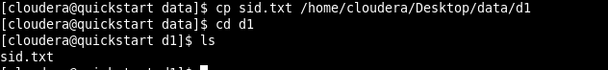

1. mv : Used to move and rename files and directories.

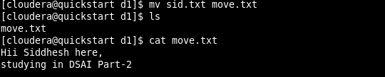

1. mkdir : Creates a new directory.

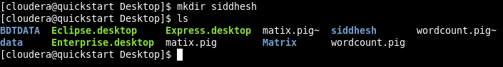

1. rmdir : Deletes the directory.

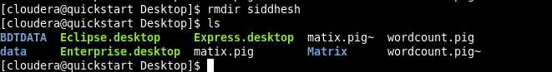

1. rm : Removes/ Deletes the file from a directory.



1. touch : Creates an empty file.

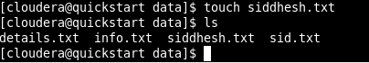

1. stat : Detail view of the file.

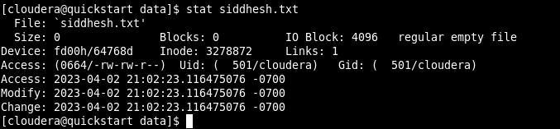

1. vi : Creates and open the file.



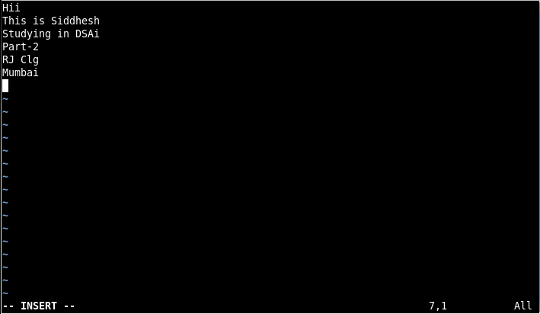

1. head : Displays the first 10 lines of a text file.

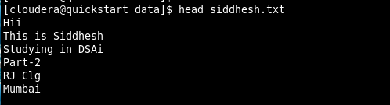

1. tail : Displays the last 10 lines of a text file.

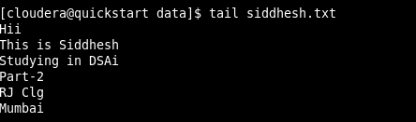

**Commands for Hadoop**

1. hadoop version : Gives the version of the hadoop.

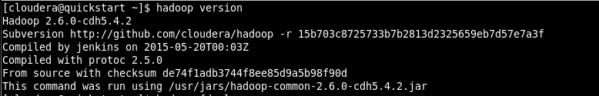

1. ls : List down all the files in hadoop.

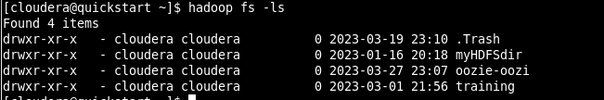

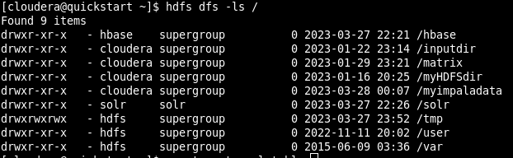

1. mkdir : Create a directory.

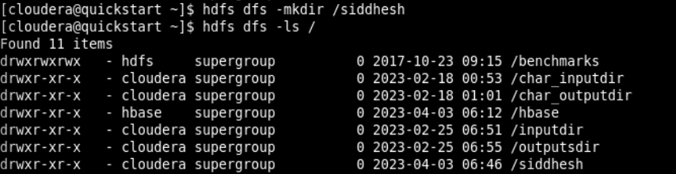

1. touchz : Creates a new file.



1. put : Copy files/folders from local file system to HDFS.



1. cat : Prints the file contents.

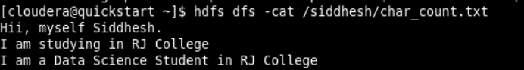

1. cp : Use to copy files within HDFS

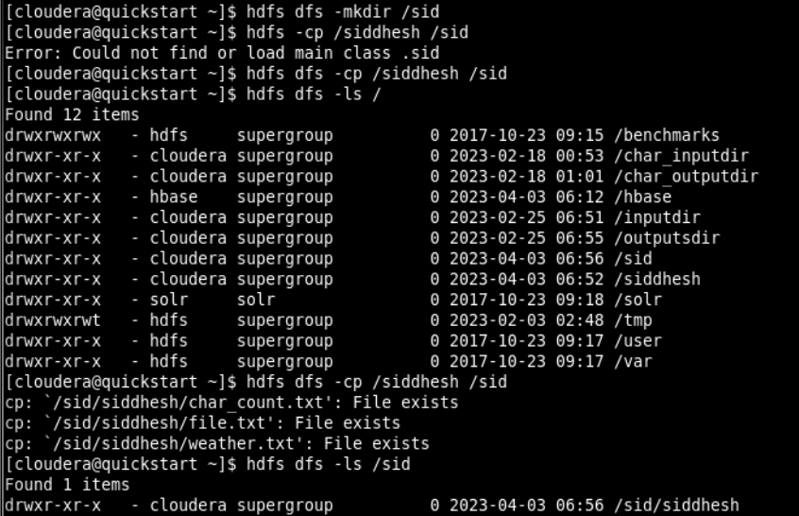

1. rm : Deletes a file from the HDFS.

